Configure BitLocker Centrally

Step 1:
In the Intune centre go to the Disk Encryption policy page
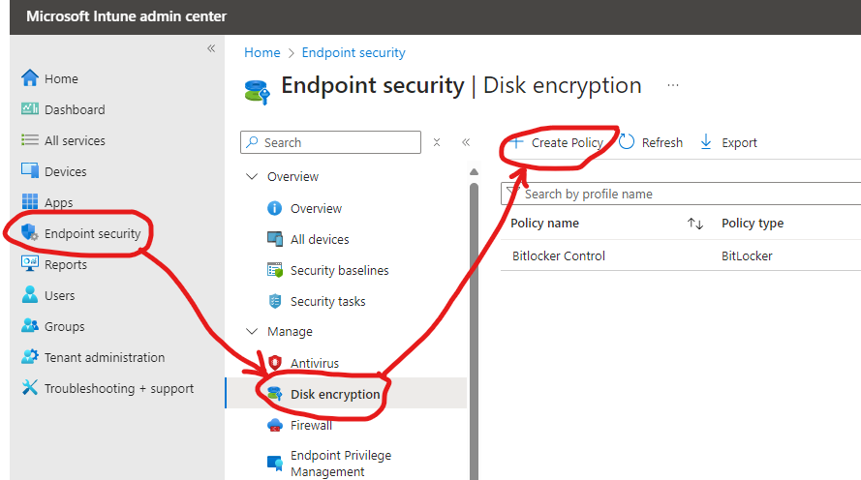
In the Create Profile page select Windows platform and BitLocker profile and click Create
Call the policy ‘BitLocker Control’
Step 2:
Create policy with settings as below
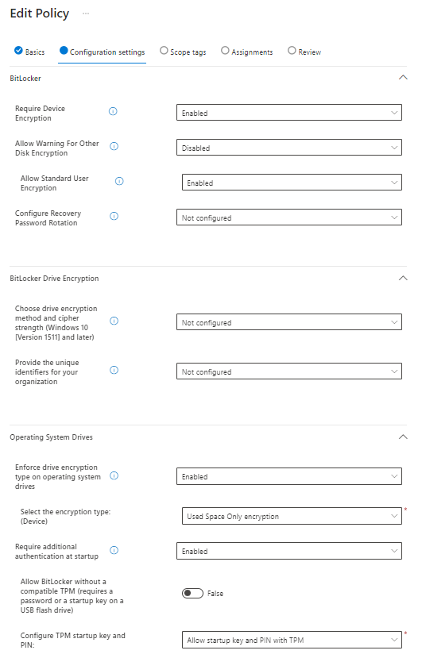
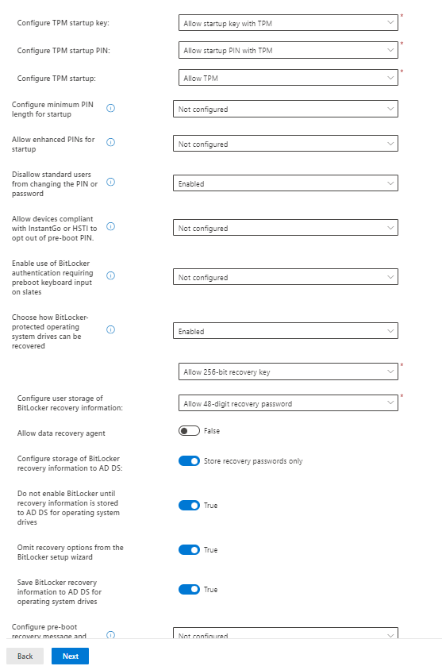
Click next, click next past scope tags and then in assignments assign to a Group unless you want to BitLocker all computers.
Click next and then Save
That should apply automatically and save the recovery keys in the intune interface. Be careful with the above settings it is easy to create a conflict and then it will stop working.
This only encrypts the C: drive, it could be expanded to do all fixed drives or even removables.

